# Part 1: Linux

## Linux

### Definition:

Linux is an open-source, Unix-like operating system kernel that forms the basis for various distributions used in servers, desktops, and embedded systems.

### Features:

1. **Open-source:** Free to use and modify.
2. **Multitasking:** Can run multiple programs simultaneously.
3. **Multiuser:** Supports multiple users at the same time.
4. **Security:** Provides strong security with permissions, user roles, and firewalls.
5. **Portability:** Works on various hardware platforms.
6. **Customization:** Highly customizable through command-line tools and various desktop environments.

### Advantages:

1. **Free and Open-source:** Cost-effective with no licensing fees.
2. **Security:** Less prone to malware and viruses.
3. **Stability:** Rarely crashes and offers long-term support.
4. **Flexibility:** Can be used for a variety of applications, from servers to embedded systems.

### Disadvantages:

1. **Learning Curve:** Complex for beginners.
2. **Software Compatibility:** Limited availability of certain proprietary software.
3. **Hardware Compatibility:** Some hardware drivers are not well-supported.

### Working:

Linux operates as a kernel that manages hardware resources, communicates between software and hardware, and schedules tasks. It provides a command-line interface (CLI) and graphical user interfaces (GUIs) through shells and desktop environments.

### Workflow:

1. **Booting:** The system loads the Linux kernel.
2. **Initialization:** The system initiates processes and services.
3. **User Interaction:** The user interacts with the system via CLI or GUI.
4. **Process Execution:** Linux handles the execution of commands or applications.
5. **Shutdown:** The system stops services and powers off.

### Components:

1. **Kernel:** Core component managing CPU, memory, and devices.
2. **System Libraries:** Provides functions for applications.
3. **System Utilities:** Basic tools for managing the OS.
4. **Shell:** User interface to execute commands.
5. **Applications:** User-level programs running on the OS.

### Lifecycle:

1. **Development:** Contributions from developers worldwide.
2. **Testing:** New versions are tested by the community.
3. **Release:** New stable distributions are released.
4. **Maintenance:** Continuous updates and patches are provided.

## Why Linux?

1. Cost-effective, secure, highly customizable, and widely used in servers, cloud computing, DevOps, and embedded systems.
2. It provides better performance and control over system processes than other OS options.

## History of Linux:

Created in 1991 by Linus Torvalds as a free alternative to Unix, Linux evolved through contributions from the open-source community and became a major OS for servers, supercomputers, and mobile devices (Android).

## Linux Kernel

### Definition:

Core component of an operating system that manages hardware and system resources.

**Example:** Linux Kernel.

### Features:

Process management, memory management, device drivers, file system management, networking.

### Advantages:

Efficient resource management, security, multitasking.

### Disadvantages:

Complex and difficult to modify directly.

### Working:

Interacts with hardware and provides services to the system via system calls.

## Linux System Libraries

### Definition:

Collection of precompiled functions used by programs to perform standard tasks.

**Example:** GNU C Library (glibc).

### Features:

Code reusability, standard APIs, abstraction of system functions.

### Advantages:

Simplifies development, reduces redundancy.

### Disadvantages:

Can introduce security vulnerabilities if outdated.

### Working:

Provides an interface for programs to interact with the kernel and hardware.

## Linux System Utilities

### Definition:

Software tools that perform system maintenance tasks.

**Example:** Disk management utilities like fdisk or system monitoring tools like top.

### Features:

Command-line interface, performs routine system tasks, accessible by the user.

### Advantages:

Simplifies system administration, enhances system performance.

### Disadvantages:

Requires technical knowledge to use effectively.

### Working:

Interacts with the kernel and system services to manage and monitor system resources.

## Linux Shell

### Definition:

Command-line interpreter that allows users to interact with the operating system.

**Example:** Bash shell.

### Features:

Command execution, scripting, automation, job control.

### Advantages:

Powerful automation, flexible, customizable.

### Disadvantages:

Steep learning curve, prone to user errors.

### Working:

Takes user commands, interprets them, and passes them to the kernel for execution.

## Linux Applications

### Definition:

End-user programs designed to perform specific tasks.

**Example:** Web browsers like Firefox, text editors like Vim.

### Features:

User interface, specific functionality, run in user space.

### Advantages:

Task-specific, wide variety of applications available.

### Disadvantages:

May depend on system resources or libraries, potential compatibility issues.

### Working:

Applications run in user space, interacting with system libraries and the kernel to perform tasks.

## Linux in DevOps

Linux is central in DevOps due to its compatibility with automation tools (e.g., Ansible, Puppet), containerization (Docker), CI/CD pipelines, and cloud environments. It provides flexibility and control needed for automation and efficient deployment workflows.

### Role of Linux in DevOps:

1. **Infrastructure Foundation:** Linux provides the core infrastructure for running servers, managing networks, and orchestrating containerized applications.
2. **Automation and Scripting:** Linux offers powerful scripting languages like Bash and Python for automating repetitive tasks and simplifying workflows. Leveraging scripting languages to automate tasks and streamline workflows.
3. Bash Scripting
4. Python Scripting
5. Anasible Playbook
6. **Community Support:** Linux boasts a vast and active open-source community, providing extensive resources, documentation, and support.
7. **Cost-Effectiveness:** Linux is open-source, reducing licensing costs and offering a flexible platform for DevOps teams.
8. **Command Line Interface (CLI):** Proficiently navigating and interacting with the Linux system using commands.
9. Navigating file systems
10. Managing processes
11. Using text editors
12. **System Administration:** Understanding system configuration, resource management, and security practices.
13. User management
14. Network configuration
15. System monitoring

### Automation and Scripting in DevOps with Linux:

Automation in DevOps streamlines repetitive tasks, improving efficiency and reducing human error. Linux scripting languages like Bash, Python, and Ruby are commonly used to write scripts that automate tasks such as deployments, system monitoring, and backups.

**Example:** Writing a Bash script on Linux to automate the deployment of applications by pulling the latest code from a repository, building it, and restarting services.

**Tools:**

1. **Bash Scripting:** A powerful scripting language for automating tasks, controlling processes, and managing system interactions.
2. **Python Scripting:** A versatile language for automating complex tasks, interacting with APIs, and building custom tools.
3. **Ansible Playbooks:** A configuration management tool for automating infrastructure provisioning, software deployment, and system configuration.

### Scaling and High Availability in DevOps with Linux:

Scaling and high availability ensure that applications remain responsive and accessible during varying loads and failures. Linux provides various tools and techniques, such as load balancers (e.g., HAProxy, Nginx) and clustering solutions (e.g., Pacemaker, Corosync), to distribute traffic and maintain uptime.

**Example:** Implementing an Nginx load balancer on Linux to distribute incoming traffic across multiple application servers, ensuring high availability and improved performance during peak times.

**Tool:**

1. **HAProxy:** A high-performance TCP/HTTP load balancer for distributing traffic across servers.
2. **NGINX:** A web server that can also function as a reverse proxy and load balancer.
3. **Keepalived:** A tool that provides load balancing and high availability for Linux servers.

### Version Control System in DevOps with Linux:

Version Control Systems (VCS) track changes to code and configurations over time. In DevOps, Git is the most widely used VCS, often hosted on Linux servers. Developers collaborate by managing branches, commits, and pull requests.

**Example:** Using Git to manage code repositories in a Linux-based DevOps environment.

**Tools:**

1. **Git:** A distributed version control system for tracking changes in source code.
2. **GitLab:** A web-based Git repository manager that provides CI/CD features.
3. **GitHub:** A popular platform for hosting Git repositories with collaboration tools.

### CI/CD in DevOps with Linux:

Continuous Integration/Continuous Deployment (CI/CD) automates the building, testing, and deployment of applications. Tools like Jenkins, GitLab CI, and CircleCI are commonly run on Linux systems to support automation pipelines.

**Example:** Jenkins on Linux triggers automated builds, tests, and deployments when code is pushed to the repository.

**Tools:**

1. **Jenkins:** An open-source automation server for building, testing, and deploying applications.
2. **GitLab CI:** Integrated CI/CD tools within GitLab for automating workflows.
3. **CircleCI:** A cloud-based CI/CD tool that automates the build and deployment processes.

### Testing in DevOps with Linux:

Automated testing ensures code quality and functionality. Linux provides a flexible environment for running unit tests, integration tests, and system tests as part of a CI/CD pipeline.

**Example:** Running automated test suites with frameworks like Selenium, PyTest, or JUnit on Linux servers.

**Tools:**

1. **JUnit:** A widely used testing framework for Java applications.
2. **Selenium:** An automated testing framework for web applications.
3. **PyTest:** A testing framework for Python that supports unit testing.

### Monitoring in DevOps with Linux:

Monitoring tools track the health and performance of applications and infrastructure. Linux-based tools like Prometheus, Nagios, and Grafana help monitor servers, applications, and containers in real-time.

**Example:** Using Prometheus to monitor CPU usage, memory consumption, and service availability in a Linux-based environment.

**Tools:**

1. **Prometheus:** An open-source monitoring and alerting toolkit designed for reliability.
2. **Grafana:** A visualization tool for monitoring data, often used with Prometheus.
3. **Nagios:** A monitoring system that checks the health of servers and applications.

### Logging in DevOps with Linux:

Logging captures events and errors to help diagnose issues and monitor system behavior. Linux provides system logging tools like syslog, journald, and ELK (Elasticsearch, Logstash, Kibana) stack for log aggregation and analysis.

**Example:** Using the ELK stack on Linux to collect and analyze application logs for troubleshooting and performance analysis.

**Tools:**

1. **ELK Stack (Elasticsearch, Logstash, Kibana):** A powerful suite for log aggregation, storage, and visualization.
2. **Fluentd:** An open-source data collector for unified logging.
3. **Graylog:** A centralized log management solution for aggregating and analyzing logs.

### Containerization in DevOps with Linux:

Containerization isolates applications in lightweight containers that share the host OS kernel but run independently. Docker is a popular containerization tool in Linux environments, allowing consistent application deployment.

**Example:** Docker on Linux to package applications and their dependencies into containers for consistent behavior across environments.

**Tools:**

1. **Docker:** A platform for developing, shipping, and running applications in containers.
2. **Podman:** A container engine that allows managing OCI containers without requiring a daemon.
3. **LXC/LXD:** Linux container technologies for lightweight virtualization.

### Container Orchestration in DevOps with Linux:

Container orchestration manages containerized applications at scale. Kubernetes is a widely used orchestration tool, often deployed on Linux, for automating the deployment, scaling, and management of containers.

**Example:** Kubernetes on Linux to manage hundreds of Docker containers across multiple hosts, ensuring high availability and scalability.

**Tools:**

1. **Kubernetes:** An open-source platform for automating deployment, scaling, and management of containerized applications.
2. **Docker Swarm:** A native clustering tool for Docker, enabling orchestration of Docker containers.
3. **Apache Mesos:** A cluster manager that provides efficient resource isolation and sharing across distributed applications.

### Configuration Management in DevOps with Linux:

Configuration management automates the setup and maintenance of system configurations. Tools like Ansible, Puppet, and Chef, typically run on Linux, allow for consistent configuration across environments.

**Example:** Using Ansible on Linux to configure servers, deploy applications, and manage infrastructure in a repeatable manner.

**Tools:**

1. **Ansible:** An open-source automation tool for configuration management and application deployment.
2. **Puppet:** A configuration management tool for automating the deployment of software and managing system configurations.
3. **Chef:** An automation platform that transforms infrastructure into code.

### IaC in DevOps with Linux:

IaC automates infrastructure provisioning and management using code. Tools like Terraform and CloudFormation on Linux help manage infrastructure as code, ensuring version control, scalability, and automation.

**Example:** Using Terraform on Linux to provision cloud infrastructure like EC2 instances, VPCs, and load balancers.

**Tools:**

1. **Terraform:** An open-source tool for building, changing, and versioning infrastructure safely and efficiently.
2. **CloudFormation:** AWS’s infrastructure as code service for managing cloud resources.
3. **Pulumi:** An open-source platform for building cloud applications using programming languages.

### Securing DevOps with Linux:

Security in DevOps is about embedding security practices in every phase of the DevOps lifecycle. Linux offers tools like SELinux, AppArmor, and iptables for securing systems, along with DevSecOps practices like automated security testing.

**Example:** Implementing SELinux on Linux servers to enforce security policies and restrict unauthorized access in a DevOps environment.

**Tools:**

1. **OpenVAS:** An open-source vulnerability scanning tool for network security.
2. **SELinux:** A Linux kernel security module that provides an additional layer of security.
3. **AIDE (Advanced Intrusion Detection Environment):** A file integrity checker that monitors changes to files and directories.

## Best Practices of Linux

1. **Regular updates:** Keep the system updated.
2. **Backup:** Regularly back up important data.
3. **Security:** Use firewalls and secure user permissions.
4. **Automation:** Automate tasks with shell scripting.
5. **Monitor:** Use monitoring tools to track performance and issues.

# Part 2: Networking

## Networking

### Definition:

Networking refers to the interconnection of computers and devices to share resources, communicate, and exchange data.

### Features:

1. Connectivity between devices
2. Resource sharing (files, printers)
3. Data transmission protocols
4. Scalability and flexibility
5. Security measures

### Advantages:

1. Improved communication and collaboration
2. Resource efficiency and sharing
3. Centralized data management
4. Enhanced security through access controls

### Disadvantages of Networking

1. Complexity in setup and maintenance
2. Security vulnerabilities
3. Dependency on network reliability
4. Potential for network congestion

### Working:

Networking works by connecting devices using hardware and protocols that facilitate data exchange over wired or wireless mediums.

### Workflow:

1. Devices communicate over a network.
2. Data packets are transmitted based on protocols.
3. Routers and switches manage data flow.
4. Users access shared resources and services.

### Components:

1. **Devices:**
2. **Routers:** Direct data packets between different networks, ensuring efficient data transmission.
3. **Switches:** Connect devices within the same network and filter data traffic by forwarding data only to intended recipients.
4. **Hubs:** Basic networking devices that connect multiple devices in a network, broadcasting data to all connected devices.
5. **Access Points:** Allow wireless devices to connect to a wired network, facilitating wireless communication.
6. **Modems:** Convert digital data to analog signals for transmission over telephone lines and vice versa.
7. **Media:**
8. **Wired Media:** Includes cables like Ethernet cables (twisted pair), coaxial cables, and fiber optic cables that physically connect devices.
9. **Wireless Media:** Utilizes radio waves to transmit data over distances without physical connections, including Wi-Fi and Bluetooth.
10. **Protocols:**
11. **TCP/IP (Transmission Control Protocol/Internet Protocol):** The fundamental protocol suite for communication over the internet.
12. **HTTP/HTTPS:** Protocols for transferring hypertext (web content) over the internet, with HTTPS providing security.
13. **FTP (File Transfer Protocol):** Used for transferring files between devices over a network.
14. **SMTP (Simple Mail Transfer Protocol):** Protocol for sending emails.
15. **Network Interface Cards (NICs):** Hardware components that allow devices to connect to a network. NICs can be wired (Ethernet) or wireless (Wi-Fi).
16. **Firewalls:** Security devices or software that monitor and control incoming and outgoing network traffic based on predetermined security rules.
17. **Load Balancers:** Distribute network or application traffic across multiple servers to enhance responsiveness and availability.
18. **Network Operating Systems:** Software that manages network resources, enabling devices to communicate, share files, and access services.
19. **Network Topology:** The layout pattern of interconnected nodes and devices in a network, defining how data flows between them and optimizing communication and resource use.

### Lifecycle:

1. **Planning:** Network design and requirements analysis.
2. **Deployment:** Installation of hardware and software.
3. **Monitoring:** Performance assessment and troubleshooting.
4. **Maintenance:** Regular updates and security checks.

### Models:

1. **OSI Model (Open Systems Interconnection):** A conceptual framework that standardizes the functions of a networking system into seven layers:
2. **Physical Layer:** Manages physical connections (cables, switches).
3. **Data Link Layer:** Ensures reliable transmission of data frames between nodes.
4. **Network Layer:** Manages routing of data packets across networks (IP addressing).
5. **Transport Layer:** Provides end-to-end communication and error recovery (TCP, UDP).
6. **Session Layer:** Manages sessions or connections between applications.
7. **Presentation Layer:** Translates data formats for the application layer.
8. **Application Layer:** Interacts with end-user applications (HTTP, FTP).
9. **TCP/IP Model:** A four-layer model that forms the basis of the internet, with layers similar to the OSI model but simplified:
10. **Link Layer:** Corresponds to the physical and data link layers of the OSI model.
11. **Internet Layer:** Manages the routing of packets (IP).
12. **Transport Layer:** Provides end-to-end communication (TCP, UDP).
13. **Application Layer:** Handles application-level protocols (HTTP, FTP, SMTP).
14. **Client-Server Model:** A networking architecture where client devices request resources or services from centralized servers. Servers process requests and return the necessary information to clients.
15. **Peer-to-Peer (P2P) Model:** A decentralized network architecture where each device (peer) can act as both a client and a server, sharing resources directly with one another without a central server.
16. **Hybrid Model:** Combines elements of client-server and peer-to-peer models, allowing for flexible resource sharing and communication.
17. **Network Architecture Models:** Various architectures like LAN (Local Area Network), WAN (Wide Area Network), MAN (Metropolitan Area Network), and CAN (Campus Area Network) define how networks are structured based on geographical coverage, size, and management.

## Why Networking?

Networking enhances communication, collaboration, and resource sharing, essential for businesses and organizations.

## History of Networking

Networking began in the 1960s with ARPANET, leading to the development of protocols and standards that formed the basis of the internet.

## Collaborative Problem-Solving Through Networking

1. **Shared Challenges:** Networking allows you to connect with others facing similar challenges, sharing insights and solutions.
2. **Collective Knowledge:** By pooling your collective knowledge, you can identify innovative solutions and overcome complex obstacles.
3. **Community Support:** Networking provides a supportive community where you can seek advice, share experiences, and collaborate on problem-solving.

## Routers

### Definition:

A router is a networking device that forwards data packets between computer networks, directing traffic to ensure data reaches its destination.

**Example:** Home routers connecting multiple devices to the internet.

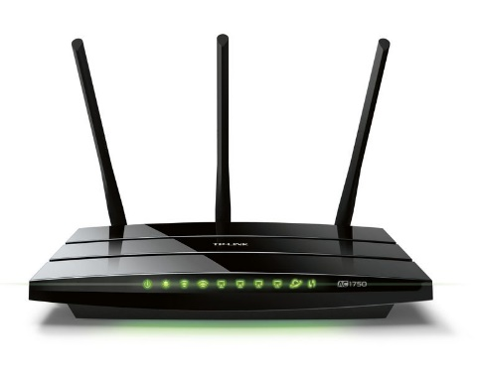

### Features:

1. Packet forwarding and routing.
2. Network address translation (NAT).
3. Firewall capabilities.
4. VPN support.

### Advantages:

1. Connects multiple networks.
2. Efficiently manages traffic and bandwidth.
3. Can provide security features.

### Disadvantages:

1. Can be complex to configure.
2. May introduce latency.

### Types:

1. **Wired routers:** Routers that connect devices through physical Ethernet cables for data transmission.
2. **Wireless routers:** Routers that provide Wi-Fi connectivity, allowing devices to connect wirelessly.
3. **Core routers:** High-performance routers at the backbone of a network, routing data within a large network.
4. **Edge routers:** Routers positioned at the boundary of a network, managing traffic between internal networks and external networks.

### Working:

Routers analyze the destination IP address of packets, using routing tables to determine the best path for forwarding data across interconnected networks.

## Switches

### Definition:

A switch is a networking device that connects devices within a local area network (LAN) and uses MAC addresses to forward data only to the intended device.

**Example:** An Ethernet switch in an office connecting computers, printers, and servers.

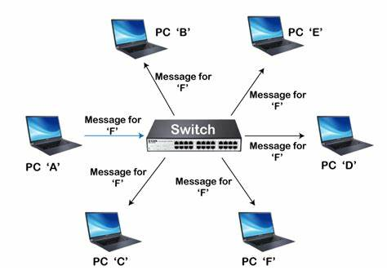

### Features:

1. MAC address learning.
2. Packet filtering and forwarding.
3. VLAN support.
4. Quality of Service (QoS) features.

### Advantages:

1. Reduces network congestion.
2. Enhances security by isolating traffic.
3. Scalable for adding more devices.

### Disadvantages:

1. Limited to local network traffic.
2. Can be costly for high-performance switches.

### Types:

1. **Managed switches:** Network switches with configurable settings and the ability to monitor and manage traffic.
2. **Unmanaged switches:** Plug-and-play switches without configuration options or traffic monitoring capabilities.
3. **Layer 2 switches:** Switches that operate at the data link layer (Layer 2), using MAC addresses to forward traffic.
4. **Layer 3 switches:** Switches that operate at both the data link (Layer 2) and network layers (Layer 3), capable of routing between VLANs.

### Working:

Switches receive incoming data packets, read their MAC addresses, and forward them only to the intended recipient within the LAN.

## Hubs

### Definition:

A hub is a basic networking device that connects multiple Ethernet devices, making them act as a single network segment.

**Example:** An older Ethernet hub used to connect computers in a small office.

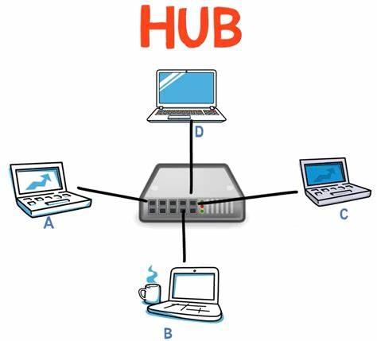

### Features:

1. Simple connectivity.
2. Broadcast transmission.

### Advantages:

1. Inexpensive and easy to set up.
2. Suitable for small networks.

### Disadvantages:

1. No intelligent data routing (all data is sent to all ports).
2. Higher chances of collisions and network congestion.

### Types:

1. **Active hubs:** Hubs that amplify signals before sending them to all connected devices.
2. **Passive hubs:** Hubs that simply forward data to all devices without amplifying the signal.
3. **Smart hubs:** Hubs with limited configuration options and intelligence for managing network traffic.

### Working:

When a hub receives a data packet, it broadcasts it to all connected devices, regardless of the destination.

## Access Points

### Definition:

An access point (AP) is a device that allows wireless devices to connect to a wired network using Wi-Fi.

**Example:** A Wi-Fi access point in a coffee shop providing internet access to customers.

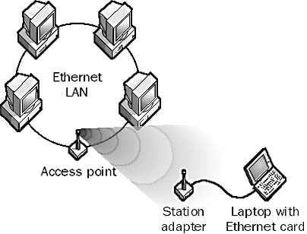

### Features:

1. Wireless connectivity.
2. DHCP server capabilities.
3. Multiple SSIDs support.

### Advantages:

1. Extends the range of a wired network.
2. Provides connectivity for mobile devices.

### Disadvantages:

1. Limited range compared to wired connections.
2. Can be subject to interference from physical obstacles.

### Types:

1. **Standalone access points:** Independent devices that provide wireless network access without requiring a controller.
2. **Controller-based access points:** Wireless access points managed centrally by a controller for easier network management.

### Working:

Access points receive data from the wired network and convert it into wireless signals, allowing wireless devices to connect.

## Modems

### Definition:

A modem (modulator-demodulator) is a device that converts digital data from a computer to analog for transmission over telephone lines and vice versa.

**Example:** A DSL modem connecting a home network to the internet.

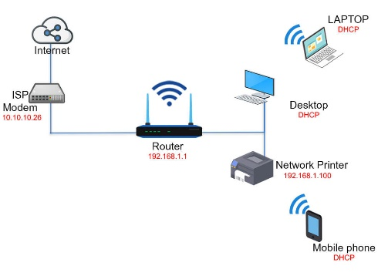

### Features:

1. Data modulation and demodulation.
2. Connection to ISP (Internet Service Provider).

### Advantages:

1. Enables internet connectivity over existing phone lines.
2. Can support multiple devices with routers.

### Disadvantages:

1. Limited speed compared to fiber optics.
2. May require configuration for specific ISPs.

### Types:

1. **DSL modems:** Modems that provide internet access over telephone lines using Digital Subscriber Line (DSL) technology.
2. **Cable modems:** Modems that provide internet access through coaxial cable connections, commonly used by ISPs.
3. **Fiber optic modems:** Modems that convert light signals from fiber optic cables into electrical signals for internet connectivity.

### Working:

Modems convert incoming analog signals from the ISP into digital data for the computer and convert outgoing digital data from the computer into analog signals for transmission.

## Wired Media

### Definition:

Wired media refers to physical transmission media that use cables to connect devices in a network.

**Example:** Ethernet cables connecting computers to a switch.

### Features:

1. High-speed transmission.
2. Stable connections with minimal interference.

### Advantages:

1. More secure than wireless connections.
2. Higher bandwidth capacity.

### Disadvantages:

1. Installation costs for cabling.
2. Limited mobility compared to wireless.

### Types:

1. **Twisted pair cables (Cat5, Cat6):** Copper cables used for Ethernet networks, with twisted pairs to reduce interference.
2. **Coaxial cables:** Thick copper cables used for cable television and internet, providing good signal shielding.
3. **Fiber optic cables:** High-speed data transmission cables that use light signals over glass fibers for long distances..

### Working:

Data is transmitted through electrical signals (in copper cables) or light signals (in fiber optics) along the physical media connecting network devices.

## Wireless Media

### Definition:

Wireless media refers to transmission media that use radio waves or infrared signals to connect devices without physical cables.

**Example:** Wi-Fi networks in homes and public spaces.

### Features:

1. Mobility for connected devices.
2. Quick and easy deployment.

### Advantages:

1. Flexibility and convenience for users.
2. Reduces cabling costs.

### Disadvantages:

1. Susceptible to interference and security threats.
2. Lower speeds compared to wired connections.

### Types:

1. **Wi-Fi (IEEE 802.11 standards):** Wireless networking technology that allows devices to communicate without cables using radio frequencies.
2. **Bluetooth:** Short-range wireless technology for connecting devices like smartphones, headphones, and peripherals.
3. **Cellular networks (3G, 4G, 5G):** Mobile networks that provide internet and communication services over radio frequencies, with increasing speed and capacity from 3G to 5G.

### Working:

Wireless devices communicate by sending and receiving data through electromagnetic waves, which are transmitted via access points or antennas.

## TCP/IP (Transmission Control Protocol/Internet Protocol)

### Definition:

TCP/IP is a suite of communication protocols used to interconnect network devices on the internet.

**Example:** The protocol used for data transmission across the internet.

### Features:

1. Packet switching.
2. Reliable data transmission (TCP).
3. Addressing and routing (IP).

### Advantages:

1. Standardized protocol widely used globally.
2. Supports multiple devices and networks.

### Disadvantages:

1. Can be complex to configure and manage.
2. Overhead may affect performance.

### Types:

1. **TCP (Transmission Control Protocol):** Reliable, connection-oriented protocol used to transmit data with error checking and flow control.
2. **UDP (User Datagram Protocol):** Connectionless, faster protocol used for applications where speed is preferred over reliability (e.g., video streaming).
3. **IP (Internet Protocol):** The protocol responsible for addressing and routing data packets across networks.

### Working:

TCP breaks down data into packets, adds addressing information, and ensures reliable delivery, while IP handles the routing of these packets to their destination.

## HTTP/HTTPS

### Definition:

HTTP (Hypertext Transfer Protocol) is the protocol used for transferring web pages on the internet, while HTTPS (HTTP Secure) adds a layer of security using SSL/TLS encryption.

**Example:** Accessing a website using http:// or https://.

### Features:

1. Stateless communication.
2. Request-response model.
3. Secure connections (HTTPS).

### Advantages:

1. Facilitates easy data exchange over the web.
2. HTTPS provides data integrity and security.

### Disadvantages:

1. HTTP is not secure, making it vulnerable to attacks.
2. Overhead of encryption in HTTPS may affect performance.

### Types:

1. **HTTP (port 80):** Protocol for transmitting web pages over the internet in plaintext using port 80.
2. **HTTPS (port 443):** Secure version of HTTP that encrypts data for secure communication over port 443.

### Working:

Clients (browsers) send requests to servers, which respond with the requested web pages. HTTPS encrypts this communication to protect sensitive data.

## FTP (File Transfer Protocol)

### Definition:

FTP is a standard network protocol used for transferring files between a client and a server over a TCP/IP network.

**Example:** Uploading files to a web server using an FTP client.

### Features:

1. Authentication (username and password).
2. Supports multiple file types and sizes.
3. Can operate in active or passive modes.

### Advantages:

1. Efficient for transferring large files.
2. Supports resuming interrupted transfers.

### Disadvantages:

1. FTP is not secure (unencrypted).
2. Complex setup for secure transfers.

### Types:

1. **Active FTP:** FTP mode where the client opens a dynamic port for the server to establish a connection back for data transfer.
2. **Passive FTP:** FTP mode where the client initiates both control and data connections, often used to navigate firewalls.
3. **Secure FTP (SFTP, FTPS):** Secure versions of FTP that encrypt data during transfer using SSH (SFTP) or TLS (FTPS).

### Working:

The client connects to the FTP server using a specified port, authenticates, and can upload or download files using commands sent to the server.

## SMTP (Simple Mail Transfer Protocol)

### Definition:

SMTP is a protocol for sending emails across networks.

**Example:** Sending an email using an email client (e.g., Outlook).

### Features:

1. Handles email sending and forwarding.
2. Works with both incoming and outgoing mail servers.

### Advantages:

1. Standardized protocol for email transmission.
2. Supports relaying of messages between servers.

### Disadvantages:

1. Vulnerable to spam and phishing attacks.
2. Lacks encryption in its basic form.

### Types:

1. **SMTP (port 25):** Protocol used for sending email messages between servers using port 25.
2. **SMTPS (secure SMTP over TLS/SSL):** Secure version of SMTP that uses TLS/SSL encryption for email transmission.

### Working:

The sender's mail server connects to the recipient's mail server using SMTP, transferring the email message for delivery.

## Network Interface Cards (NICs)

### Definition:

A Network Interface Card (NIC) is a hardware component that allows devices to connect to a network.

**Example:** Ethernet NIC in a desktop computer.



### Features:

1. Wired or wireless connectivity.
2. Data transmission speed (e.g., 100Mbps, 1Gbps).

### Advantages:

1. Enables device networking capabilities.
2. Supports multiple connection types (Ethernet, Wi-Fi).

### Disadvantages:

1. May require drivers and software for configuration.
2. Hardware limitations can affect performance.

### Types:

1. **Ethernet NICs:** Network Interface Cards (NICs) that provide wired network connectivity using Ethernet cables.
2. **Wireless NICs (Wi-Fi):** NICs that provide wireless connectivity using Wi-Fi to connect devices to a network.
3. **Fiber optic NICs:** NICs that connect devices to fiber optic networks, allowing high-speed data transfer over fiber optic cables.

### Working:

The NIC converts digital data from the computer into signals that can be transmitted over a network medium, and vice versa.

## Firewalls

### Definition:

A firewall is a network security device that monitors and controls incoming and outgoing network traffic based on predetermined security rules.

**Example:** A hardware firewall protecting a corporate network.

### Features:

1. Packet filtering.
2. Stateful inspection.
3. Virtual private network (VPN) support.

### Advantages:

1. Provides a barrier against external threats.
2. Can log and analyze traffic for security.

### Disadvantages:

1. Misconfiguration can lead to security gaps.
2. Can introduce latency to network traffic.

### Types:

1. **Hardware firewalls:** Dedicated physical devices that monitor and control incoming and outgoing network traffic.
2. **Software firewalls:** Programs installed on devices to monitor and filter network traffic based on predefined rules.
3. **Next-generation firewalls (NGFW):** Advanced firewalls that provide deeper inspection, threat detection, and application control.

### Working:

Firewalls inspect data packets, applying rules to allow or block traffic based on security policies.

## Load Balancers

### Definition:

A load balancer is a device or software that distributes network or application traffic across multiple servers to ensure no single server becomes overwhelmed.

**Example:** A load balancer directing traffic to web servers hosting a popular website.

### Features:

1. Health checks to monitor server availability.
2. SSL termination for secure connections.
3. Session persistence.

### Advantages:

1. Enhances application availability and responsiveness.
2. Improves resource utilization.

### Disadvantages:

1. Can be a single point of failure if not redundant.
2. May introduce complexity in configuration.

### Working:

Load balancers receive incoming traffic and distribute it to available servers based on algorithms like round-robin, least connections, or IP hash.

## Network Operating Systems

### Definition:

A network operating system (NOS) is software that controls network resources and enables communication between devices on a network.

**Example:** Microsoft Windows Server or Linux-based servers.

### Features:

1. File and print services.
2. User and security management.
3. Network management and monitoring.

### Advantages:

1. Centralized management of network resources.
2. Enhanced security and user authentication.

### Disadvantages:

1. May require extensive training for administration.
2. Licensing costs for proprietary systems.

### Types:

1. **Windows Server:** A server operating system from Microsoft that manages network resources and services in enterprise environments.
2. **Linux (Ubuntu Server, CentOS):** Open-source server operating systems widely used for web hosting, development, and cloud services.
3. **Novell NetWare:** A legacy network operating system used for file and print sharing in early enterprise networks.

### Working:

NOS manages hardware and software resources, enabling file sharing, application access, and device communication within the network.

## OSI Model (Open Systems Interconnection Model)

### Definition:

The OSI Model is a conceptual framework used to understand and implement network communications in seven layers.

**Example:** Networking protocols like HTTP and TCP operate at specific layers of the OSI model.

### Features:

1. Standardized communication protocols.
2. Layered architecture, allowing for modular design.
3. Facilitates interoperability between different systems.

### Advantages:

1. Helps in troubleshooting by isolating network issues to specific layers.
2. Simplifies the design and understanding of network protocols.

### Disadvantages:

1. Can be overly complex for practical applications.
2. Not all protocols fit neatly into the seven layers.

### Layers:

1. **Physical Layer:** Transmission of raw data bits over a physical medium.
2. **Data Link Layer:** Node-to-node data transfer and error detection/correction.
3. **Network Layer:** Routing data between devices across different networks.
4. **Transport Layer:** Reliable data transfer and flow control (e.g., TCP).
5. **Session Layer:** Managing sessions and connections between applications.
6. **Presentation Layer:** Data formatting, encryption, and translation.
7. **Application Layer:** User interface and application services.

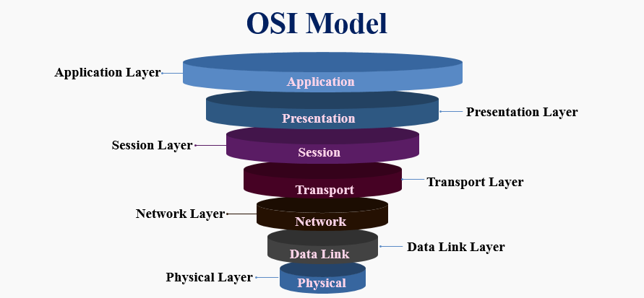

### Working:

Data is encapsulated as it moves down through the layers, with each layer adding its own header or trailer. At the receiving end, data is decapsulated as it moves up through the layers.

## TCP/IP Model (Transmission Control Protocol/Internet Protocol Model)

### Definition:

The TCP/IP Model is a simplified, four-layer framework used for understanding and implementing network communication over the internet.

**Example:** Internet communication protocols like HTTP, FTP, and SMTP operate within the TCP/IP model.

### Features:

1. Supports a wide range of networking protocols.
2. Designed for robustness and flexibility in network communications.
3. Enables communication between devices on different networks.

### Advantages:

1. More streamlined than the OSI model with fewer layers.
2. Widely used and accepted as the foundation for the internet.

### Disadvantages:

1. Can be less detailed compared to the OSI model.
2. Some functionalities overlap between layers.

### Layers:

1. **Application Layer:** Provides network services to end-user applications (e.g., HTTP, FTP).
2. **Transport Layer:** Provides end-to-end communication and reliability (e.g., TCP, UDP).
3. **Internet Layer:** Handles routing and addressing of packets (e.g., IP).
4. **Link Layer:** Manages the physical and logical connection to the network (e.g., Ethernet).

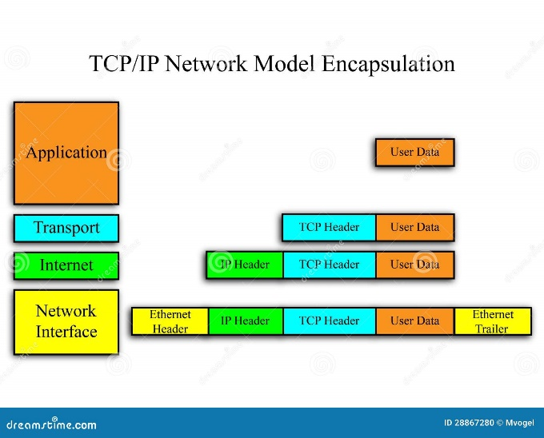

### Working:

Data from applications is passed down through the layers, where each layer adds necessary information for transmission. The data is then transmitted over the network and received at the destination, where it is processed in reverse order.

## Client-Server Model

### Definition:

The Client-Server Model is a distributed application structure that divides tasks between providers of a resource or service (servers) and service requesters (clients).

**Example:** A web application where a browser (client) requests data from a web server.

### Features:

1. Centralized control of resources on the server.
2. Separation of user interface and data processing.
3. Typically involves multiple clients accessing a single server.

### Advantages:

1. Easy to manage and scale.
2. Centralized security and data management.

### Disadvantages:

1. Server can become a bottleneck if overloaded.
2. Requires constant server availability for client access.

### Working:

Clients send requests to the server for resources or services, and the server processes these requests and sends back the appropriate responses.

## Peer-to-Peer (P2P) Model

### Definition:

The Peer-to-Peer (P2P) Model is a decentralized communication model where each participant (peer) acts as both a client and a server, sharing resources directly with each other.

**Example:** File-sharing networks like BitTorrent.

### Features:

1. Decentralized architecture without a central server.
2. Direct communication between peers.
3. Resource sharing and collaboration.

### Advantages:

1. Scalability and resilience due to the absence of a central point of failure.
2. Efficient resource utilization.

### Disadvantages:

1. Security concerns due to lack of centralized control.
2. Complexity in managing and maintaining connections.

### Working:

Peers connect with each other directly, sharing resources and services without going through a centralized server. Each peer can send and receive data, making requests and providing resources.

## Hybrid Model

### Definition:

The Hybrid Model combines elements of both client-server and peer-to-peer architectures, allowing for flexible resource sharing and communication.

**Example:** Modern cloud services where clients access centralized resources while also sharing data directly with each other.

### Features:

1. Flexible resource allocation.
2. Combines the advantages of both models.
3. Supports various communication methods.

### Advantages:

1. Optimizes resource usage and network performance.
2. Allows for redundancy and scalability.

### Disadvantages:

1. Complexity in implementation and management.
2. Potential conflicts between centralized and decentralized systems.

### Working:

Clients may request services from a central server while also sharing data directly with other clients, balancing centralized management with peer collaboration.

## Network Architecture Models

### Definition:

Network Architecture Models refer to the structural design of a network, defining how different components communicate and interact with each other.

**Example:** Star, mesh, and bus network topologies.

### Features:

1. Defines the layout and organization of network components.
2. Determines data flow and communication protocols.

### Advantages:

1. Provides a framework for designing and implementing networks.
2. Enhances network efficiency and performance.

### Disadvantages:

1. Can be expensive and complex to implement.
2. Requires careful planning and consideration of network requirements.

### Working:

Data travels through the defined architecture based on the chosen topology, with each design impacting data transmission efficiency and fault tolerance.

## Bus Topology

### Definition:

A single central cable (the bus) connects all devices in a network.

**Example:** Early Ethernet networks.

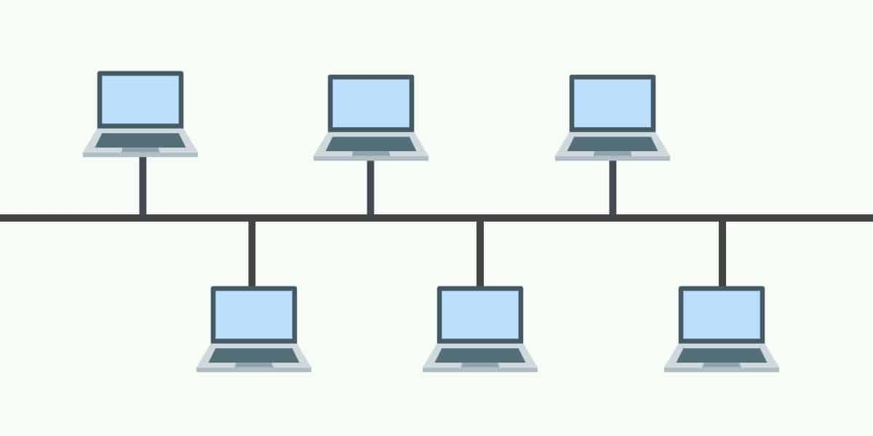

### Features:

1. All devices share the same communication line.
2. Termination is required at both ends of the bus to prevent signal bounce.

### Advantages:

1. Easy to set up and extend.
2. Requires less cable than star topology.

### Disadvantages:

1. Limited cable length and number of devices.
2. If the main cable fails, the entire network goes down.

## Star Topology

### Definition:

All devices are connected to a central hub or switch.

**Example:** Modern Ethernet networks.

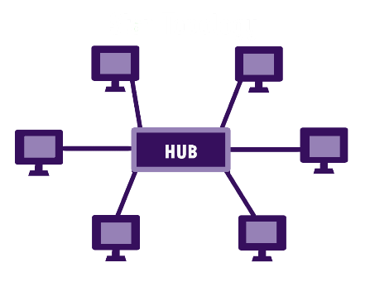

### Features:

1. Each node connects to a central point (hub/switch).
2. Data transfers through the central hub.

### Advantages:

1. Easy to install and manage.
2. Failure of one cable or device doesn’t affect others.

### Disadvantages:

1. If the central hub fails, the entire network goes down.
2. Requires more cable than bus topology.

## Ring Topology

### Definition:

Each device is connected to two other devices, forming a circular data path.

**Example:** Token Ring networks.

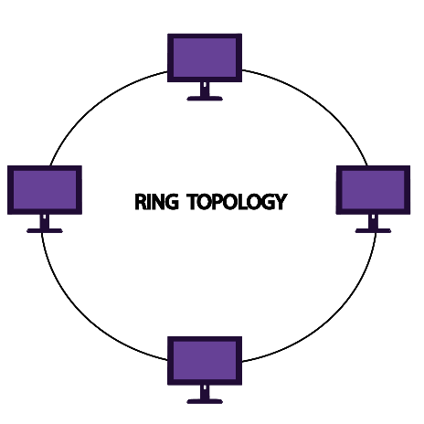

### Features:

1. Data travels in one direction (or two in a dual ring).
2. Each device acts as a repeater to keep the signal strong.

### Advantages:

1. Predictable data transmission times.
2. Simple to manage and install.

### Disadvantages:

1. A failure in any cable or device can disrupt the entire network.
2. More difficult to troubleshoot than star topology.

## Mesh Topology

### Definition:

Every device is connected to every other device, allowing for multiple paths for data transmission.

**Example:** Advanced and critical networks like military and industrial systems.

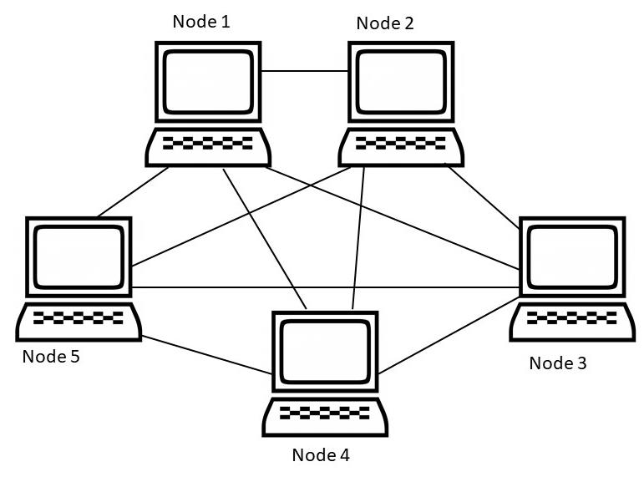

### Features:

1. Provides redundancy and reliability.
2. Can be fully connected (every device connects to every other) or partially connected.

### Advantages:

1. Highly reliable; if one connection fails, data can take another route.
2. Excellent for load balancing.

### Disadvantages:

1. Expensive due to a high number of cables and network ports.
2. Complex installation and maintenance.

## Tree Topology

### Definition:

A hybrid topology that combines characteristics of star and bus topologies. It has a hierarchical structure with a root node and several levels of connected nodes.

**Example:** Corporate networks that connect multiple departments.

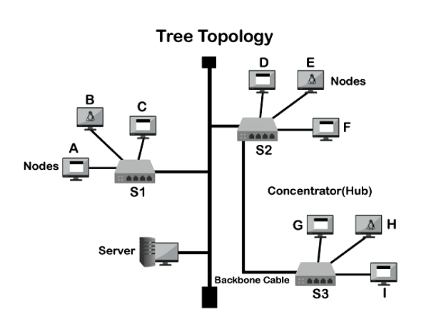

### Features:

1. Groups of star-configured networks are connected to a linear bus backbone.
2. Central hub for each branch.

### Advantages:

1. Scalable; easy to add more nodes.
2. Central management is easier.

### Disadvantages:

1. If the backbone line fails, segments of the network may be disconnected.
2. More complex than simple topologies.

## Hybrid Topology

### Definition:

Combines two or more different topologies to form a resultant topology tailored for specific needs.

**Example:** A mix of star and ring topologies in a single network.

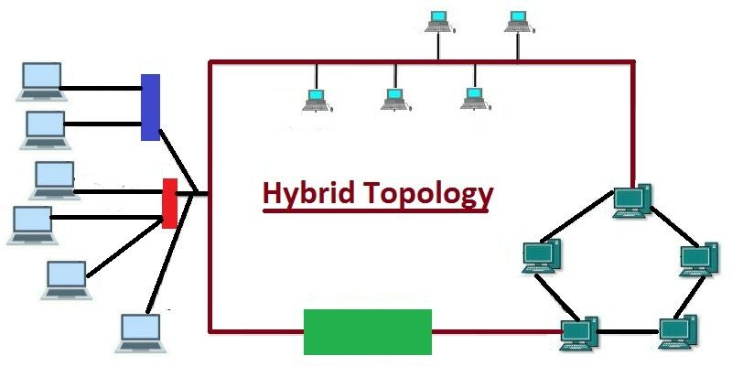

### Features:

1. Flexible design that can accommodate various network needs.
2. Can be expanded easily.

### Advantages:

1. Can leverage the strengths of different topologies.
2. Customized to suit organizational needs.

### Disadvantages:

1. Complex design can make troubleshooting more difficult.
2. Higher costs due to varied components.

## Networking in DevOps

Networking is crucial in DevOps for enabling collaboration, automating processes, and managing cloud infrastructure.

Networking in DevOps refers to the practices, tools, and methodologies that facilitate communication and collaboration between development and operations teams through effective network design and management. It encompasses the interconnection of various systems, services, and applications to ensure seamless data flow, accessibility, and reliability.

### Key Aspects of Networking in DevOps

1. **Collaboration and Communication:** Networking enables real-time communication between teams, breaking down silos between development and operations. Tools like chat applications, video conferencing, and collaboration platforms rely on robust networking to enhance teamwork.
2. **Continuous Integration and Continuous Deployment (CI/CD):** Networking plays a critical role in CI/CD pipelines, where code changes need to be automatically tested, built, and deployed. Reliable network connections ensure that code repositories are accessible, enabling developers to push changes and trigger automated workflows without interruption.
3. **Infrastructure Management:** In a DevOps environment, infrastructure is often managed as code (IaC). Networking configurations can be defined in scripts (using tools like Terraform or Ansible) to automate the provisioning of network resources, such as virtual networks, subnets, and firewalls, along with compute and storage resources.
4. **Microservices Communication:** Many DevOps practices involve deploying applications as microservices. Networking is essential for enabling communication between these services, ensuring they can discover each other, exchange data, and work together effectively. Service meshes like Istio and Linkerd can be used to manage inter-service communication, security, and observability.
5. **Monitoring and Performance:** Networking tools are employed to monitor application performance and network traffic, providing insights into how applications behave under different loads. Tools like Prometheus and Grafana are often integrated to visualize network metrics and detect anomalies, ensuring applications remain performant.
6. **Security:** Networking in DevOps also encompasses security practices. This includes implementing firewalls, VPNs, and secure access controls to protect data and applications. Automated security testing and monitoring tools can help identify vulnerabilities in both network configurations and application code.
7. **Scalability and High Availability:** Networking solutions must support scaling applications to handle varying loads. Load balancers distribute incoming traffic across multiple servers to ensure high availability and performance. Redundant network paths and failover mechanisms ensure that applications remain accessible even in the event of network failures.
8. **Logging and Diagnostics:** Networking involves capturing logs related to network traffic, application interactions, and security events. These logs are essential for diagnosing issues, performing root cause analysis, and improving overall system performance.

### The Importance of Networking in DevOps:

1. **Knowledge Sharing:** Networking facilitates the exchange of ideas, best practices, and solutions to common challenges.
2. **Collaboration:** Networking fosters a sense of community and collaboration, enabling individuals to work together towards common goals.
3. **Innovation:** Networking exposes you to diverse perspectives and encourages the generation of creative ideas and innovative solutions.
4. **Career Growth:** Networking expands your professional network, opening doors to new opportunities and career advancement.

### Building Connections within the DevOps Community:

1. **Professional Organizations:** Organizations like DevOps Institute, AWS, and Microsoft Azure offer networking opportunities through events, online communities, and certifications.
2. **Meetups and Events:** Local meetups and conferences provide platforms for connecting with professionals in your area, sharing knowledge, and building relationships.
3. **Online Forums:** Participate in online forums, discussion boards, and social media groups dedicated to DevOps, engaging in discussions and connecting with others.

### Cultivating a Diverse and Inclusive DevOps Network:

1. **Representation:** Actively seek out and engage with individuals from diverse backgrounds, fostering a more inclusive and representative DevOps community.
2. **Openness:** Create a welcoming and inclusive environment where everyone feels comfortable sharing their perspectives and contributing to the community.
3. **Collaboration:** Foster collaboration among individuals with different experiences, skills, and perspectives, leading to more innovative solutions.

## Best Practices of Networking

1. Regularly update hardware and software.
2. Implement strong security measures.
3. Monitor network performance.
4. Use documentation for network management.

# Part 3: Python

## Python

### Definition:

Python is a high-level, interpreted programming language known for its simplicity, readability, and versatility. It supports multiple programming paradigms, including procedural, object-oriented, and functional programming.

### Features:

1. **Simple & Readable Syntax:** Python’s syntax is clean and easy to understand, making it ideal for beginners.
2. **Interpreted Language:** Python code is executed line by line, allowing easy debugging.
3. **Cross-Platform:** Python can run on various platforms, including Windows, macOS, and Linux.
4. **Extensive Standard Library:** Python has a vast library that provides tools for many domains like web development, data science, and machine learning.
5. **Dynamic Typing:** Variables do not need explicit declaration, simplifying code.
6. **Object-Oriented:** Supports classes and objects for OOP.
7. **Integration Capabilities:** Python integrates well with C, C++, and Java.

### Advantages:

1. **Ease of Use:** Its simple syntax allows developers to focus on solving problems rather than syntax errors.
2. **Community Support:** Python has a vast community and a wealth of resources, tutorials, and third-party libraries.
3. **Versatile:** Can be used for web development, automation, data analysis, AI, and more.
4. **Productivity:** High-level abstractions, rapid prototyping, and fewer lines of code enhance productivity.

### Disadvantages:

1. **Performance Limitations:** Python is slower than compiled languages like C++ and Java.
2. **Memory Consumption:** Python is not memory-efficient and may be unsuitable for memory-intensive applications.
3. **Mobile Development:** Python is not commonly used for mobile applications.
4. **Weak in Multithreading:** Python's Global Interpreter Lock (GIL) limits multithreading performance.

### Working:

Python is an interpreted language, which means code is executed by the Python interpreter line by line. When Python code is run, it is first compiled into bytecode and then executed by the Python Virtual Machine (PVM).

### Workflow:

1. **Write Code:** Develop Python scripts using a text editor or IDE.
2. **Execute Code:** Python’s interpreter runs the code.
3. **Debugging:** Errors are detected during runtime, and logs/errors are shown.
4. **Refinement:** Based on debugging, the code is optimized.
5. **Deployment:** Final scripts are executed in production.

### Syntax and Structure:

Python uses indentation (whitespace) to define code blocks, unlike other languages that use braces or semicolons. Its syntax is highly readable and minimalistic.

**Example:**

def greet(name):

print(f"Hello, {name}!")

### Architecture:

1. **Interpreter:** Executes the code.
2. **Bytecode:** Python source code is compiled into intermediate bytecode.
3. **PVM (Python Virtual Machine):** Executes the bytecode.
4. **Standard Library:** Contains built-in modules and functions to facilitate different tasks.
5. **Third-Party Libraries:** Expand Python’s capabilities through packages like NumPy, pandas, Flask, etc.

### Components:

1. **Syntax and Semantics:** Define the rules for writing Python code.
2. **Libraries and Modules:** Pre-built functions and tools for various tasks.
3. **Interpreter:** Translates Python code to machine language.
4. **PVM:** Python’s runtime engine to execute the bytecode.

### Lifecycle:

1. **Writing:** Writing Python scripts or modules.
2. **Execution:** Running code using the Python interpreter.
3. **Compilation:** Python internally compiles code to bytecode before execution.
4. **Error Handling:** Errors encountered during execution are resolved.
5. **Optimization:** Code is optimized based on performance or scalability needs.
6. **Deployment:** The final product is deployed for end users.

### Framework:

Popular Python frameworks include:

1. **Django:** Full-stack web development framework.
2. **Flask:** Lightweight web development framework.
3. **FastAPI:** High-performance framework for building APIs.
4. **Pyramid:** Flexible web development framework.

## Why Python?

1. **Ease of Learning:** Simple syntax, making it suitable for beginners.
2. **Versatility:** Can be used in web development, automation, data science, AI, and more.
3. **Extensive Libraries:** Python has an extensive set of libraries, reducing development time.

## History of Python

Python was created by Guido van Rossum in 1991. It was designed to be simple, easy to understand, and extensible. Python has gone through several versions, with Python 2 and Python 3 being the most significant. Python 3.x is the current version, with many improvements over Python 2.

## Python API

### Definition:

A Python API (Application Programming Interface) is a set of defined rules that allow communication between different software components using Python. It enables developers to interact with external services, libraries, or programs via requests and responses in a standardized format, such as JSON or XML.

### Features:

1. **Simplicity:** Python APIs are easy to use and understand, making them beginner-friendly.
2. **Interoperability:** APIs allow Python programs to interact with external services, such as databases or web services.
3. **Scalability:** Python APIs are lightweight and can handle large-scale data.
4. **Modularity:** Python APIs can be divided into reusable modules.
5. **Flexibility:** Python APIs support multiple data formats like JSON, XML, and more.
6. **Asynchronous Support:** APIs in Python can handle asynchronous requests for improved performance.
7. **Extensibility:** Python APIs are extendable with custom endpoints, allowing for integration with other systems.
8. **Security:** APIs can implement authentication and authorization mechanisms such as OAuth or JWT.

### Advantages:

1. **Ease of Use:** Python APIs can be integrated easily with other Python programs and services, speeding up development.
2. **Cross-Platform Compatibility:** APIs in Python can work across various platforms (Windows, Linux, macOS).
3. **Extensive Libraries:** Python APIs have access to a vast ecosystem of libraries, such as requests, Flask, Django, and FastAPI.
4. **Strong Community Support:** Python APIs have a large developer base, offering rich resources and documentation.
5. **Efficient Data Handling:** Python APIs can work with large datasets efficiently using formats like JSON and XML.
6. **Testing:** Python APIs are easier to test using frameworks like PyTest, and tools like Postman or Swagger.

### Disadvantages:

1. **Performance:** Python APIs are slower compared to APIs written in lower-level languages like C++ or Go.
2. **Concurrency Limitations:** Due to Python's Global Interpreter Lock (GIL), Python APIs may not perform optimally in multi-threaded applications.
3. **Memory Usage:** Python APIs tend to consume more memory due to Python's high-level abstractions.
4. **Limited for Mobile Applications:** Python APIs are not widely used in mobile development, unlike Java or Swift APIs.

### Working:

Python APIs work by creating endpoints that users or applications can call to perform specific actions (like data retrieval, insertion, or updating). These APIs use protocols like HTTP/HTTPS and exchange data in formats like JSON or XML.

1. **Request:** The client sends a request (e.g., GET, POST) to the API server.
2. **Processing:** The API processes the request, retrieves, or manipulates the data from databases or services.
3. **Response:** The API returns a response, typically in JSON or XML format, back to the client.

### Workflow:

1. **Client Request:** The client sends an HTTP request to the API endpoint.
2. **Routing:** The API framework routes the request to the corresponding function based on the HTTP method (GET, POST, etc.) and URL.
3. **Processing Logic:** The server-side function processes the request, interacts with databases or services, and performs the necessary computations.
4. **Response:** The API sends the response back to the client in a structured format (JSON, XML).
5. **Error Handling:** In case of errors, the API provides meaningful error responses, such as 404 (Not Found) or 500 (Internal Server Error).

### Syntax and Structure:

Python APIs are typically written using frameworks such as Flask, Django, or FastAPI. They allow you to define endpoints and routes for handling different HTTP methods like GET, POST, PUT, and DELETE.

**Example:**

from flask import Flask, jsonify, request

app = Flask(__name__)

@app.route('/api/hello', methods=['GET'])

def hello_world():

return jsonify({"message": "Hello, World!"})

if __name__ == "__main__":

app.run(debug=True)

This example defines a GET endpoint at /api/hello, which returns a JSON response.

### Architecture:

1. **Client-Server Architecture:** APIs in Python follow a client-server architecture where clients request data, and servers respond.
2. **Statelessness:** APIs in Python are stateless, meaning each request is treated independently.
3. **RESTful Architecture:** Most Python APIs follow REST (Representational State Transfer) principles, offering endpoints for data retrieval (GET), creation (POST), updating (PUT), and deletion (DELETE).
4. **Endpoint Definition:** Endpoints define the URLs where the API accepts requests.
5. **Middleware:** Middleware components can intercept requests/responses for logging, authentication, etc.
6. **Response Handling:** Standard response codes (200 OK, 404 Not Found, etc.) are sent to the client.
7. **Authentication Layer:** Security mechanisms such as OAuth or JWT ensure only authorized users can access the API.
8. **Database Layer:** APIs often interact with databases to fetch or store information.

### Components:

1. **Endpoints:** URLs where requests are sent.
2. **HTTP Methods:** GET, POST, PUT, DELETE, etc., for interacting with the API.
3. **Request Payload:** Data sent to the API.
4. **Response Payload:** Data sent back to the client.
5. **Framework:** Tools like Flask, Django, or FastAPI used to build the API.
6. **Database:** Where data is stored and retrieved for API requests.
7. **Authentication:** OAuth, JWT, or API keys for securing the API.

### Lifecycle:

1. **Design:** Plan the endpoints, data models, and operations.
2. **Development:** Write code for each endpoint using a Python framework.
3. **Testing:** Validate API behavior with unit tests and tools like Postman or Swagger.
4. **Deployment:** Deploy the API to a server or cloud service.
5. **Monitoring:** Monitor the API performance and uptime.
6. **Maintenance:** Continuously update and improve the API as needed.

### Framework:

Python APIs are commonly built using the following frameworks:

1. **Flask:** A lightweight, microframework suitable for small projects.
2. **Django:** A full-stack framework that includes ORM and many built-in features.
3. **FastAPI:** A modern, high-performance framework ideal for building APIs with automatic OpenAPI documentation.

## Why Python API?

1. **Ease of Development:** Python APIs are simple to write and debug.
2. **Integration:** APIs in Python can easily integrate with web apps, mobile apps, and other external services.
3. **Rapid Prototyping:** Python’s flexibility allows developers to create functional APIs quickly.
4. **Scalability:** Python APIs can scale horizontally by adding more instances.
5. **Community and Libraries:** The Python ecosystem has rich libraries and tools for building APIs.

## Python in DevOps

Python is extensively used in DevOps for automation, configuration management, and scripting. Python libraries like Fabric and Ansible are used for automating tasks, and Python scripts are commonly used to interact with APIs or cloud services.

### Lifecycle:

1. **Develop Scripts:** Automate infrastructure management using Python scripts.
2. **Testing:** Unit tests ensure code quality.
3. **CI/CD:** Python scripts are integrated into CI/CD pipelines.
4. **Deployment:** Scripts are deployed to production environments.
5. **Monitoring:** Tools monitor the execution of Python scripts and processes.

### Version Control System in DevOps with Python

Git is the most common VCS used with Python in DevOps. Python code is managed in repositories, allowing developers to track changes, collaborate, and manage versions of the codebase.

1. **Collaboration:** Python projects can be managed using Git for effective collaboration among team members.
2. **Version History:** Git tracks changes made to Python code, allowing teams to revert to previous versions if necessary.
3. **Branching Strategy:** Facilitates development of features in isolated branches, promoting cleaner integration.
4. **Integration with CI/CD:** Version control systems seamlessly integrate with CI/CD pipelines to automate testing and deployment processes.
5. **Code Review:** Enables peer reviews of Python code changes through pull requests, improving code quality.

### Continuous Integration and Deployment Pipelines

1. **Code Commit:** Trigger automated builds and tests when code is pushed to a version control system.
2. **Testing and Validation:** Execute unit, integration, and functional tests to ensure code quality and functionality.
3. **Deployment:** Deploy applications to different environments, including development, staging, and production.
4. **Monitoring and Feedback:** Collect performance data and user feedback to identify potential issues and improve future releases.

Python scripts can be incorporated into CI/CD pipelines using tools like Jenkins or GitLab CI. Continuous integration tools run Python scripts for building, testing, and deploying code automatically.

1. **Automated Builds:** CI/CD tools automate the building of Python applications, ensuring that each commit is compiled and ready for deployment.
2. **Continuous Testing:** Integrates automated testing frameworks (like pytest) to validate code quality at every stage.
3. **Faster Releases:** Speeds up the delivery process by automating the deployment of Python applications to various environments.
4. **Environment Consistency:** Ensures consistency across environments (development, staging, production) using Docker or virtual environments.
5. **Rollback Capabilities:** CI/CD pipelines can quickly roll back to previous versions of Python applications in case of failures.

### Testing and Quality Assurance in Python

1. **Unit Testing:** Test individual functions and components of the codebase.
2. **Integration Testing:** Verify the interaction between different parts of the application.
3. **End-to-End Testing:** Simulate real-world user scenarios to ensure the entire system works as intended.

Python testing frameworks like unittest, pytest, and nose are used for testing Python applications. Automated tests ensure code quality before deployment in a DevOps pipeline.

1. **Unit Testing:** Encourages writing unit tests for Python code using frameworks like unittest and pytest to validate functionality.
2. **Integration Testing:** Facilitates testing interactions between various components of a Python application.
3. **Test Automation:** Automates the execution of tests, ensuring quick feedback on code quality and performance.
4. **Code Coverage:** Tools like coverage.py provide insights into test coverage, helping identify untested parts of the code.
5. **Error Reporting:** Integrates with CI/CD pipelines to report errors immediately, aiding rapid debugging and fixing.

### Monitoring and Logging with Python

1. **Data Collection:** Python libraries gather system metrics, log events, and performance data from various sources.
2. **Data Processing:** Python scripts analyze and process data, identifying trends, anomalies, and potential issues.
3. **Visualization and Reporting:** Python tools create visualizations and reports to present insights and facilitate decision-making.

Monitoring tools like Nagios, Prometheus, and Zabbix integrate with Python scripts to track system health, application performance, and infrastructure usage.

1. **Metrics Collection:** Utilizes libraries like prometheus_client to expose application metrics for monitoring performance.
2. **Real-Time Insights:** Dashboards in tools like Grafana provide real-time insights into the health of Python applications.
3. **Alerting Mechanisms:** Configures alerts based on metrics to notify teams of potential issues before they escalate.
4. **Performance Monitoring:** Tracks resource usage (CPU, memory) and application performance metrics, enabling proactive scaling.
5. **Log Integration:** Combines with logging solutions to correlate metrics and logs for better troubleshooting.

### Logging in DevOps with Python:

Python’s logging module is used to log events, errors, and system activities, enabling better tracking of Python applications in production environments.

1. **Structured Logging:** Uses Python’s logging module to create structured logs for better analysis.
2. **Centralized Log Management:** Integrates with log management tools (like ELK stack) to centralize log storage and analysis.
3. **Debugging Aid:** Provides detailed logging information that helps developers identify and fix issues efficiently.
4. **Log Rotation:** Implements log rotation to manage log size and prevent storage issues.
5. **Error Tracking:** Integrates with tools like Sentry to track errors and exceptions in real time.

### Containerization in DevOps with Python:

Python applications can be containerized using Docker. Python code and dependencies are packaged into a container, making it easier to deploy across different environments.

1. **Docker Integration:** Uses Docker to create containerized environments for Python applications, ensuring consistency across environments.
2. **Simplified Deployment:** Facilitates deployment of Python applications through Docker images, making it easy to run in various environments.
3. **Environment Isolation:** Each container runs in its own isolated environment, reducing conflicts between dependencies.
4. **Version Control for Containers:** Docker images can be versioned, allowing for easy rollbacks to previous application states.
5. **Scalability:** Enables easy scaling of Python applications by running multiple containers as needed.

### Container Orchestration in DevOps with Python:

Python-based containers can be orchestrated using Kubernetes or Docker Swarm. Kubernetes manages scaling, deployment, and load balancing for Python containerized applications.

1. **Kubernetes Deployment:** Utilizes Kubernetes to manage the deployment and scaling of containerized Python applications.
2. **Automated Scaling:** Automatically scales Python applications based on resource usage and demand.
3. **Load Balancing:** Distributes traffic to multiple instances of Python applications to ensure high availability.
4. **Health Monitoring:** Monitors the health of containers and restarts them if necessary, maintaining application uptime.
5. **Declarative Configuration:** Uses YAML files to define application configurations, promoting infrastructure as code practices.

### Configuration Management with Python

1. **Infrastructure Configuration:** Python scripts manage system settings, software packages, and network configurations, ensuring consistency across environments.
2. **Version Control:** Configuration files are stored in version control systems, allowing for tracking changes and rollbacks.
3. **Automation:** Python tools automate repetitive configuration tasks, reducing errors and improving efficiency.

Python integrates with tools like Ansible, SaltStack, and Chef to automate configuration management. Python scripts help manage server configuration across environments.

1. **Ansible Integration:** Leverages Ansible for automating infrastructure setup and configuration using Python scripts.
2. **Consistency Across Environments:** Ensures that all environments (development, testing, production) are configured identically.
3. **Automated Provisioning:** Automates the installation and configuration of software dependencies for Python applications.
4. **Idempotency:** Ensures that applying configurations multiple times results in the same state, avoiding unintended changes.
5. **Version Control:** Configuration scripts can be version-controlled, allowing for easy tracking of changes and rollbacks.

### IaC in DevOps with Python:

1. **Configuration Management:** Use Python libraries like Ansible or SaltStack to manage infrastructure configuration, ensuring consistency and repeatability.
2. **Infrastructure Provisioning:** Python helps automate the creation and setup of cloud resources on platforms like AWS, Azure, and GCP.
3. **Deployment Automation:** Python scripts facilitate the deployment of applications and services to different environments, reducing manual errors and improving speed.

Python is used in infrastructure as code (IaC) practices with tools like Terraform and AWS CloudFormation. Python scripts help define infrastructure declaratively, automating resource provisioning.

1. **Configuration Management:** Use Python libraries like Ansible or SaltStack to manage infrastructure configuration, ensuring consistency and repeatability.
2. **Infrastructure Provisioning:** Python helps automate the creation and setup of cloud resources on platforms like AWS, Azure, and GCP.
3. **Deployment Automation:** Python scripts facilitate the deployment of applications and services to different environments, reducing manual errors and improving speed.

### Securing DevOps with Python:

Python scripts can automate security tasks, such as vulnerability scanning, monitoring logs for suspicious activity, and automating security patches. Python integrates with security tools to ensure compliance and prevent vulnerabilities.

1. **Security Automation:** Automates security checks and compliance validation in CI/CD pipelines using Python scripts.
2. **Static Code Analysis:** Uses tools like Bandit to analyze Python code for security vulnerabilities before deployment.
3. **Secrets Management:** Integrates with secrets management tools (like HashiCorp Vault) to securely handle sensitive data in Python applications.
4. **Monitoring and Alerting:** Implements monitoring for security events and alerts teams of suspicious activities.
5. **Access Controls:** Uses Python libraries to enforce access control and authentication mechanisms in applications, ensuring data protection.

## Scalable and Resilient Systems with Python

1. **Cloud Computing:** Python leverages cloud platforms to provide scalable resources and infrastructure, adapting to changing demands.
2. **Load Balancing:** Python implements load balancing strategies to distribute traffic across multiple servers, enhancing performance and reliability.
3. **Security:** Python helps secure systems by automating security checks, vulnerability assessments, and incident response.
4. **Monitoring and Alerting:** Python scripts monitor system health and trigger alerts when performance thresholds are exceeded.

## Serverless Computing with Python

1. **Serverless Functions:** Python functions are deployed as serverless units, executing code on demand without managing servers.
2. **Cloud Platform Integration:** Serverless functions seamlessly integrate with cloud services like AWS Lambda, Azure Functions, and Google Cloud Functions.

## Best Practices of Python

1. **PEP 8 Compliance:** Follow Python’s style guide.
2. **Write Modular Code:** Break down code into functions and classes.
3. **Use Virtual Environments:** Isolate dependencies for different projects.
4. **Write Tests:** Ensure code quality by writing unit tests.
5. **Use Meaningful Names:** For variables and functions.
6. **Optimize Code:** Avoid writing redundant code.